



**CS4001NI Programming**

**Second Milestone**

**2025 Spring**

**Student Name: Alisha Maharjan**

**London Met ID: 24046561**

**College ID: NP01AI4A240078**

**Group: AI 3**

**Assignment Due Date: Sunday, April 13, 2025**

**Assignment Submission Date: Sunday, April 13, 2025**

*I confirm that I understand my coursework needs to be submitted online via MySecondTeacher under the relevant module page before the deadline in order for my assignment to be accepted and marked. I am fully aware that late submissions will be treated as non-submission and a marks of zero will be awarded.*

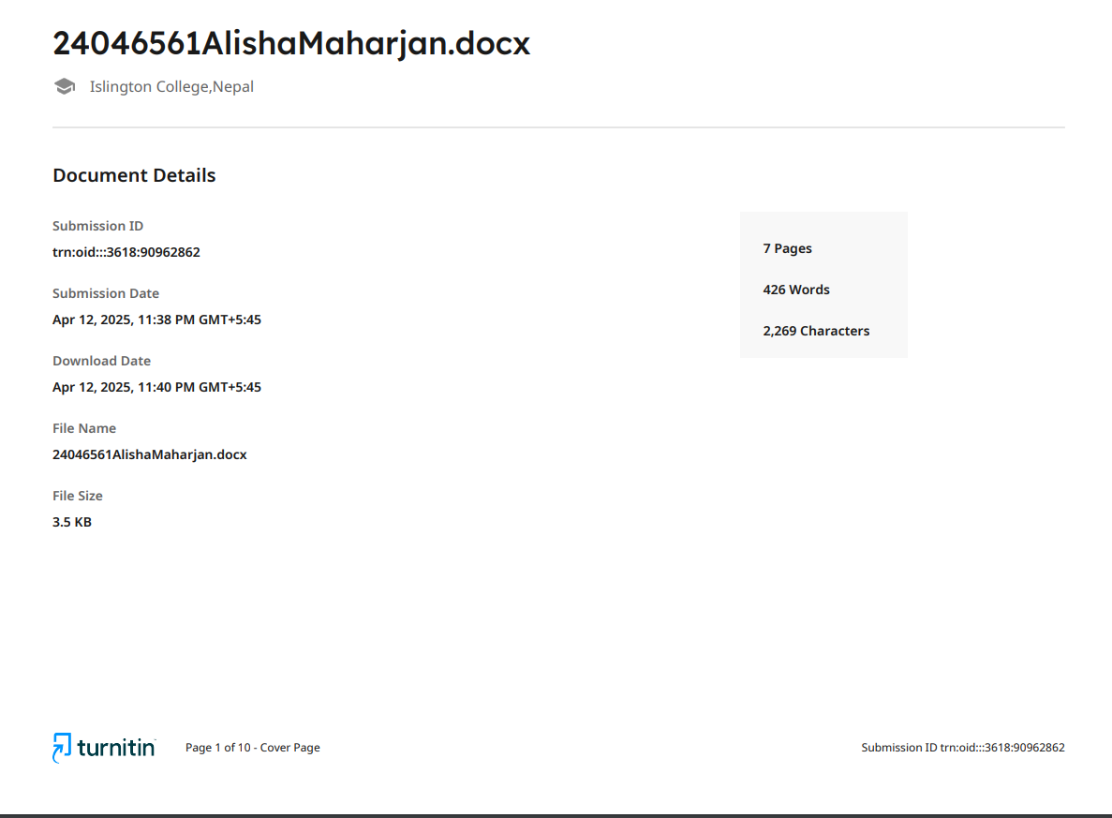

Table of Contents

Introduction 7

Wireframe For GUI Design 7

Screenshot of Developed GUI 8

Testing 9

Test 1: Compile and run the program using command prompt/terminal 9

Test 2: Adding regular and premium member respectively 10

Test 3: Test Case for Mark Attendance 12

Table of Figures

Figure 1: Wireframe Design 8

Figure 2: Developed GUI 9

Figure 3: Compiling and running the program in the terminal 10

Figure 4: Test for regular member 11

Figure 5:Test for premium member 12

Figure 6: Test for mark attendance 13

# Introduction

This project focuses on developing a system to manage members of a gym with different types of membership plans. This project also keeps the track of the members who visits the gym by keeping attendance and their accumulated loyalty points. In this project each member is defined by a unique ID and has the personal details like their name, location, phone number, email, address, membership start date, and membership plan. This project is developed by using BlueJ.

The aim of this project is to use object-oriented concept of Java by implementing in a real-world problem scenario which includes a class to represent a GymMember with its two subclasses RegularMember and PremiumMember respectively. The main objective of this project is to implement a graphical user interface (GUI). The goal is to create the Gym Member details within an array list. This class contains the main method and will be executed via the command prompt. This project also explains about the functionality and structure of a program.

# Wireframe For GUI Design

Figure 1: Wireframe Design

# Screenshot of Developed GUI

Figure 2: Developed GUI

# Testing

## Test 1: Compile and run the program using command prompt/terminal

Table 1: Test 1: Compile and run the program using terminal

|  |  |
| --- | --- |
| Objective | To compile and run the program in the terminal. |
| Action | The program was opened in the terminal and necessary command was provided. |
| Expected Output | The GymGUI frame should be opened. |
| Actual Output | The GymGUI frame was opened. |
| Result | The test was successful. |

Figure 3: Compiling and running the program in the terminal

## Test 2: Adding regular and premium member respectively

Table 2: Test-2: Adding regular and premium member respectively

|  |  |
| --- | --- |
| Objective | To add a regular and a premium member respectively. |
| Action | All the required fields were filled, and “Add a Regular Member” and “Add a Premium Member” Button was clicked. |
| Expected Output | The regular and premium members details should be added successfully with an appropriate message dialog box. |
| Actual Output | The regular and premium members details were added successfully with an appropriate message dialog box. |
| Result | The test was successful. |

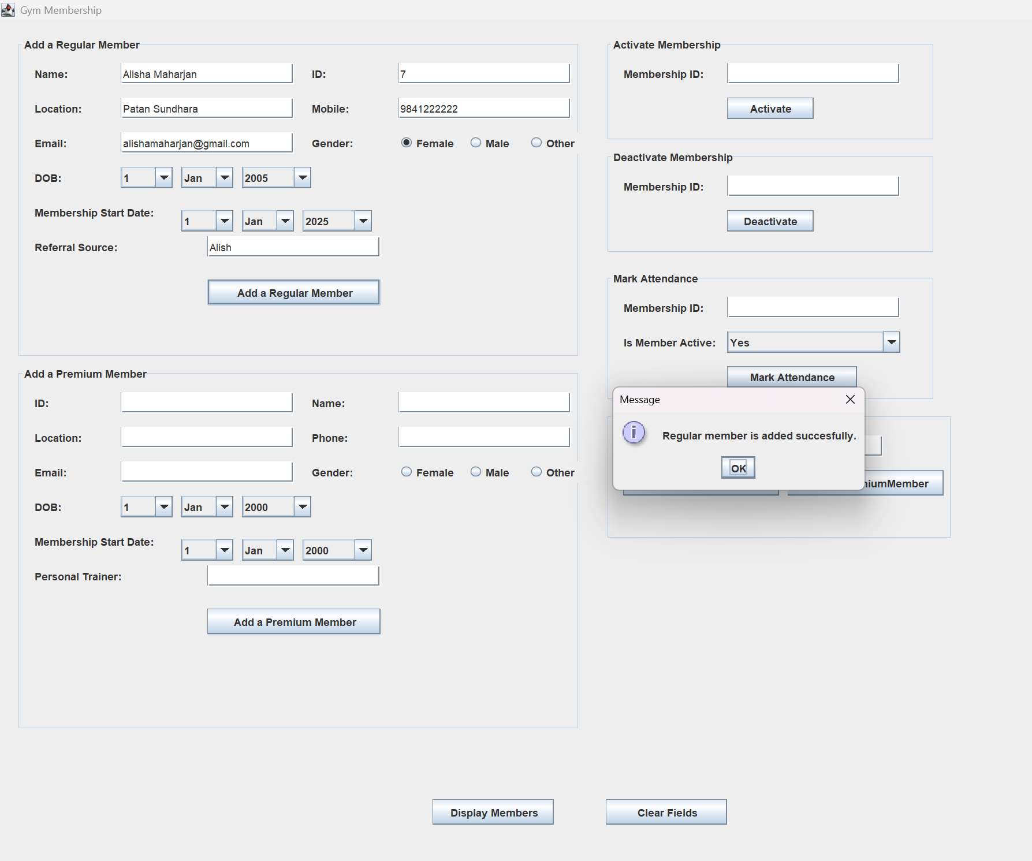

Figure 4: Test for regular member

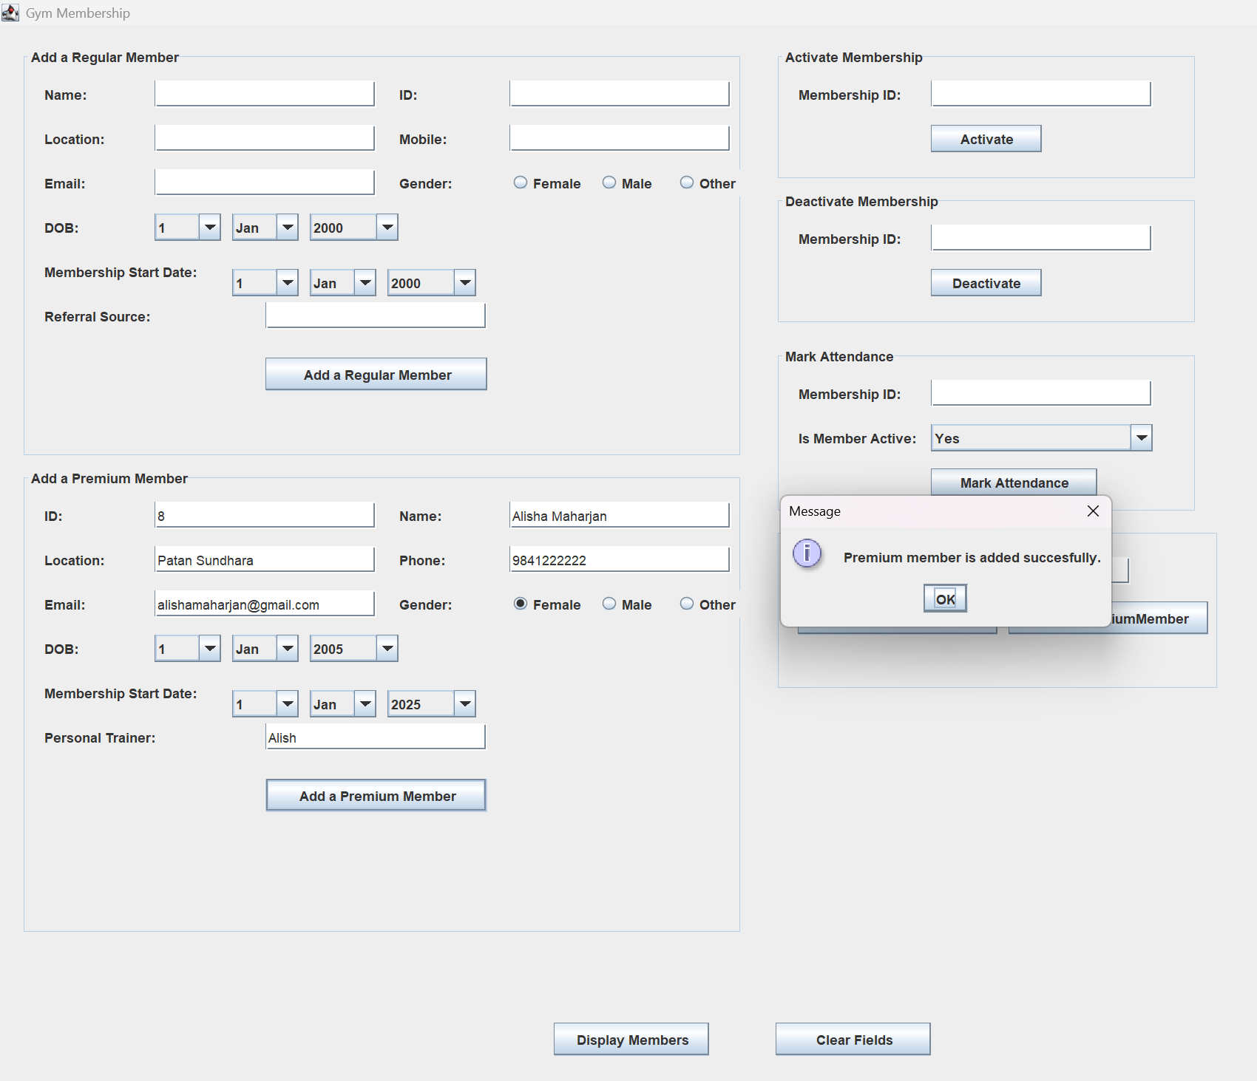

Figure 5:Test for premium member

## Test 3: Test Case for Mark Attendance

Table 3: Test-3: Test Case for Mark Attendance

|  |  |
| --- | --- |
| Objective | To mark the attendance. |
| Action | The required text fields were filled, and mark attendance button was clicked. |
| Expected Output | The attendance should be marked successfully with an appropriate message dialog box. |
| Actual Output | The attendance was marked successfully with an appropriate message dialog box. |
| Result | The test was successful. |

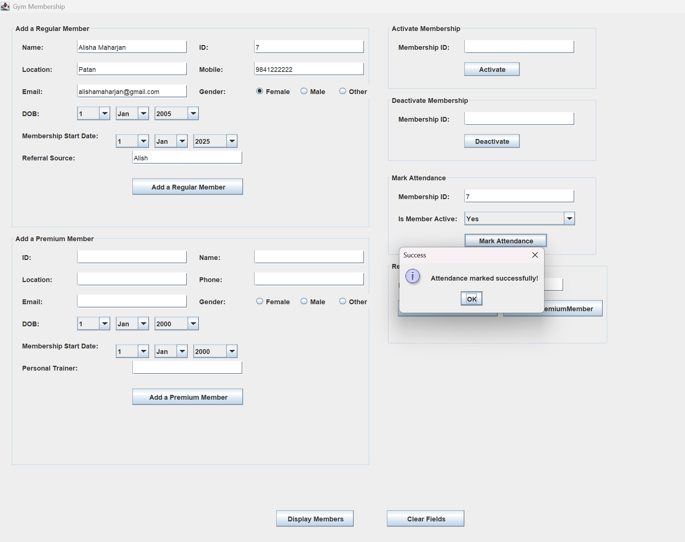

Figure 6: Test for mark attendance